In our measurements the dark blue was the clock and the light blue was the output of the counter.

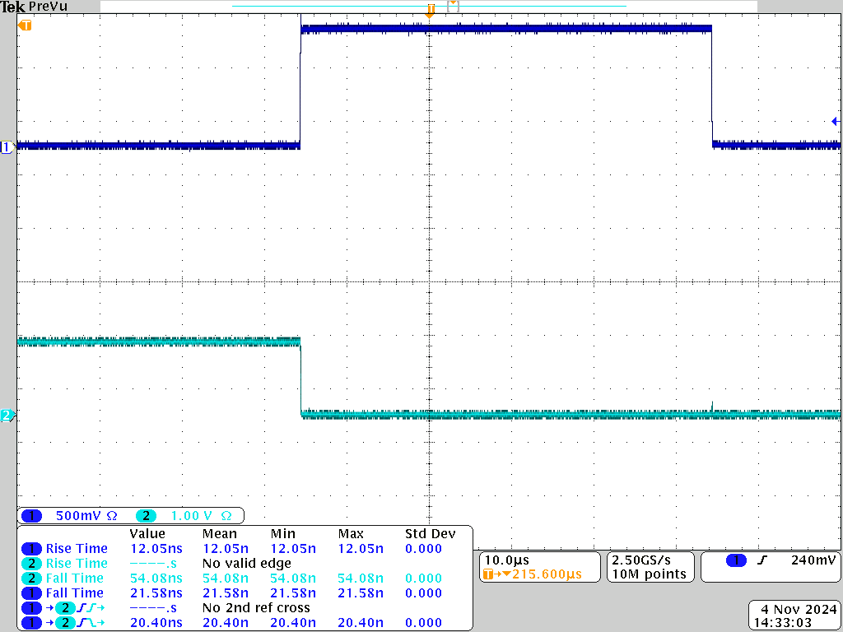

Figure 1: 10 Khz propagation delay high to low measurement

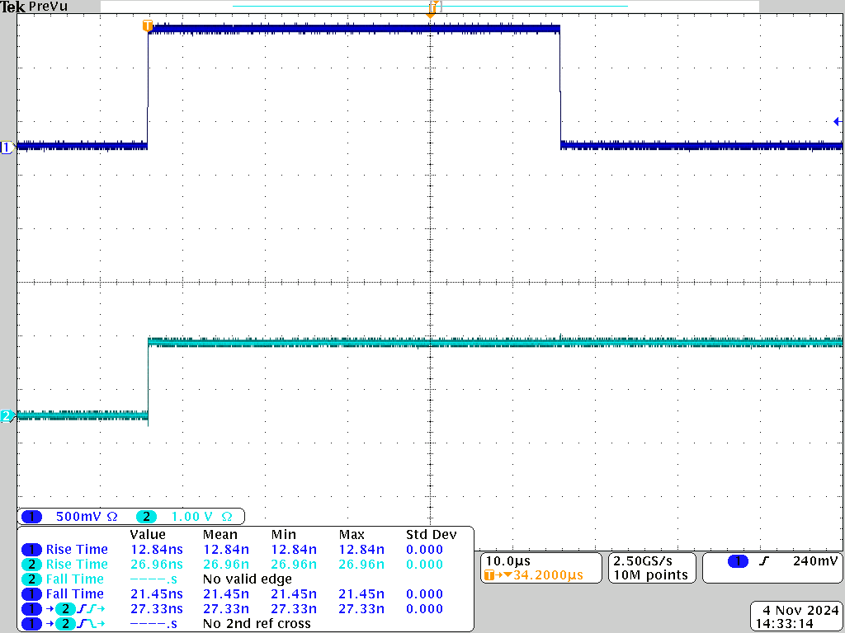Figure 2: 10 Khz propagation delay low to high measurement

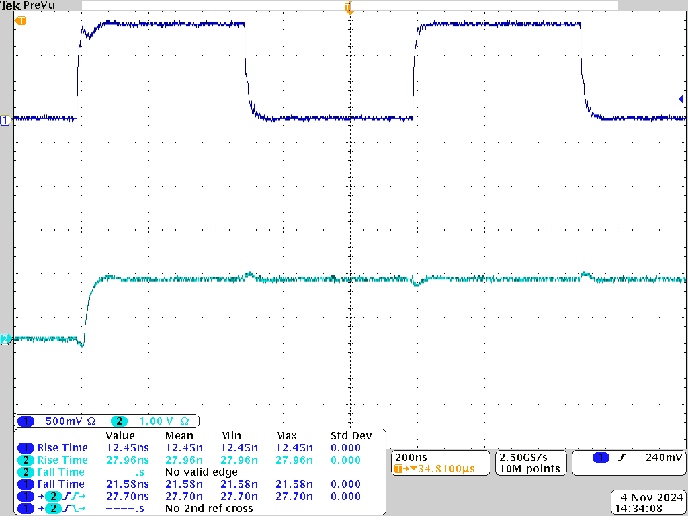Figure 3: 1 Mhz propagation delay low to high measurement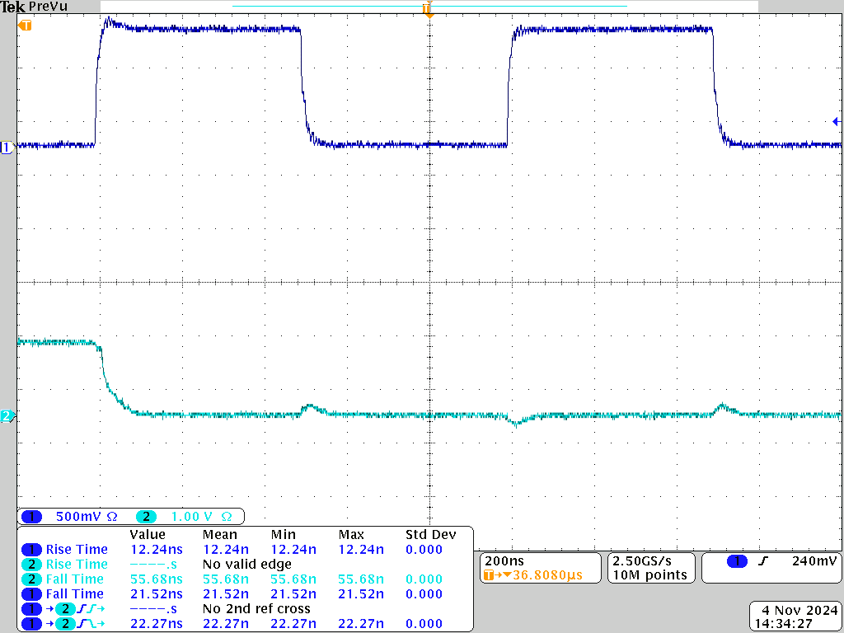Figure 4: 1 Mhz propagation delay high to low measurement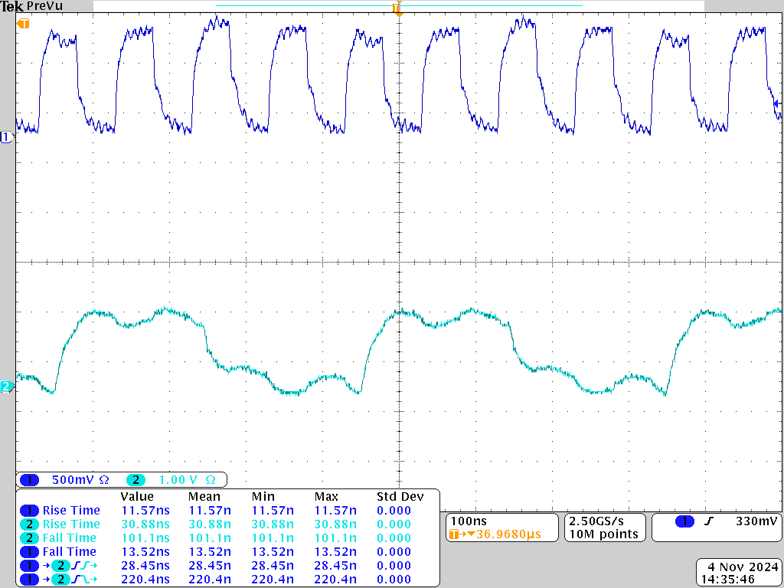Figure 5: 10 Mhz propagation delay low to high measurement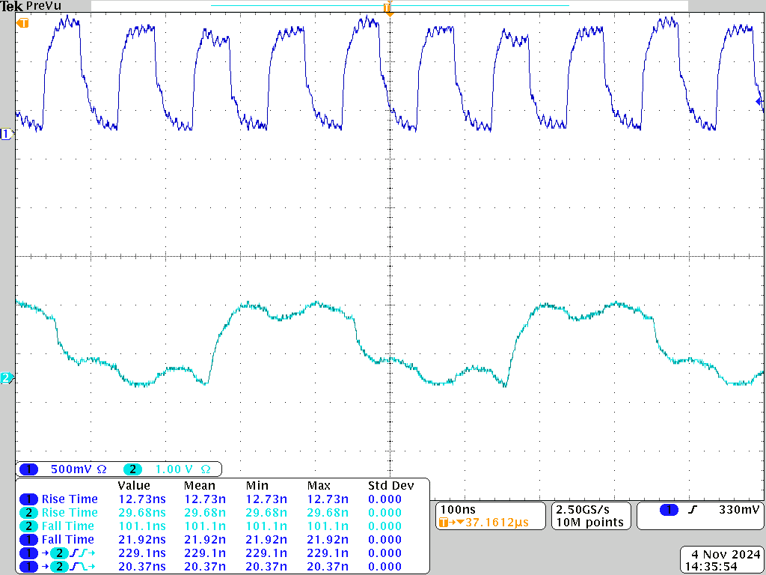Figure 6: 10 Mhz propagation delay high to low measurement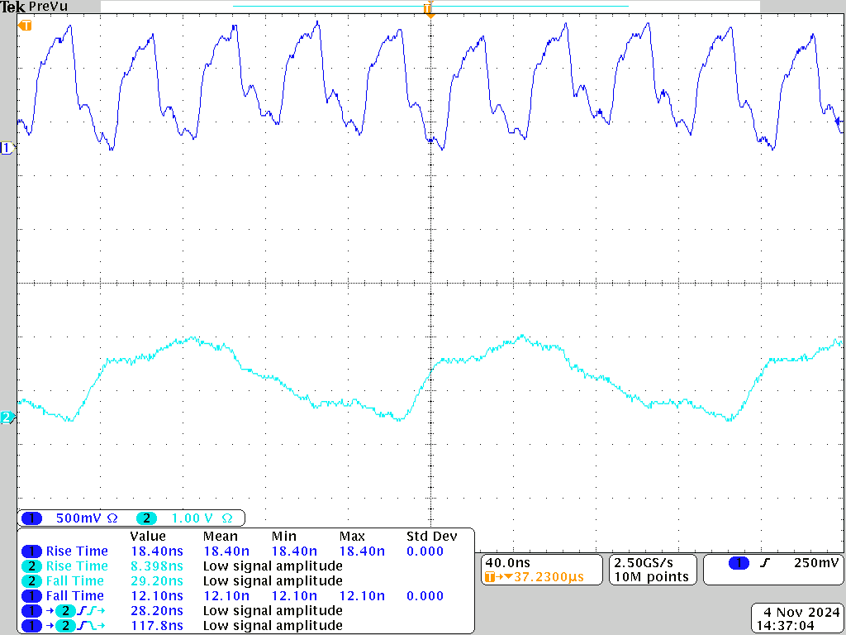Figure 7: 25 Mhz waveform 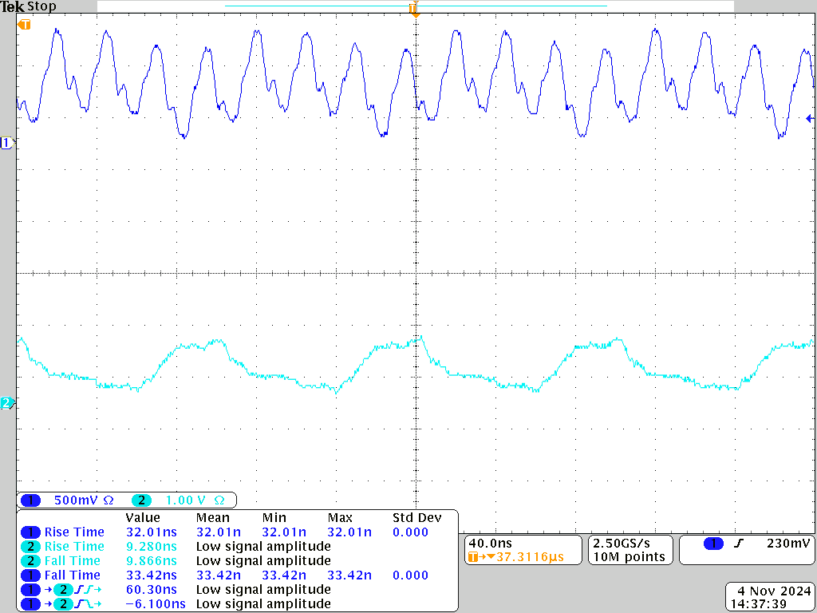Figure 8: 40 Mhz waveform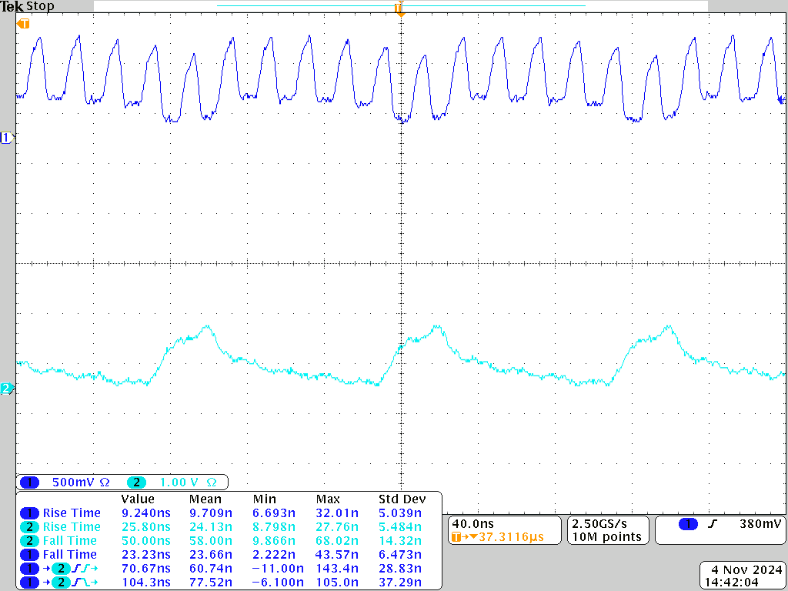Figure 9: 50 Khz waveform

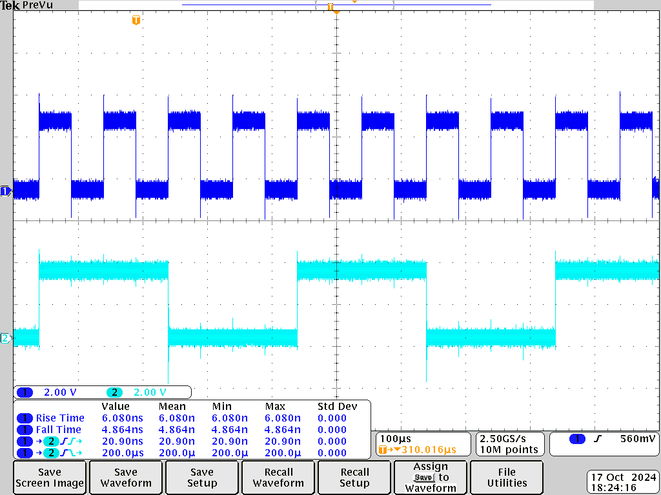

Figure 10 Waveform of the expected number of switches per clock.

**Error Analysis**

Figure 10 shows the output is a rising edge triggered and switches every 2nd edge or completes the cycle after every 4th clock. Based on this we can see that in Figure 9 the clock no longer follows this trend and is likely too fast for the circuit to handle. As shown by the analysis below in Figure 11 where the 50 Mhz clock did not switch on every second clock edge but instead would complete a full cycle after 6 clocks instead.

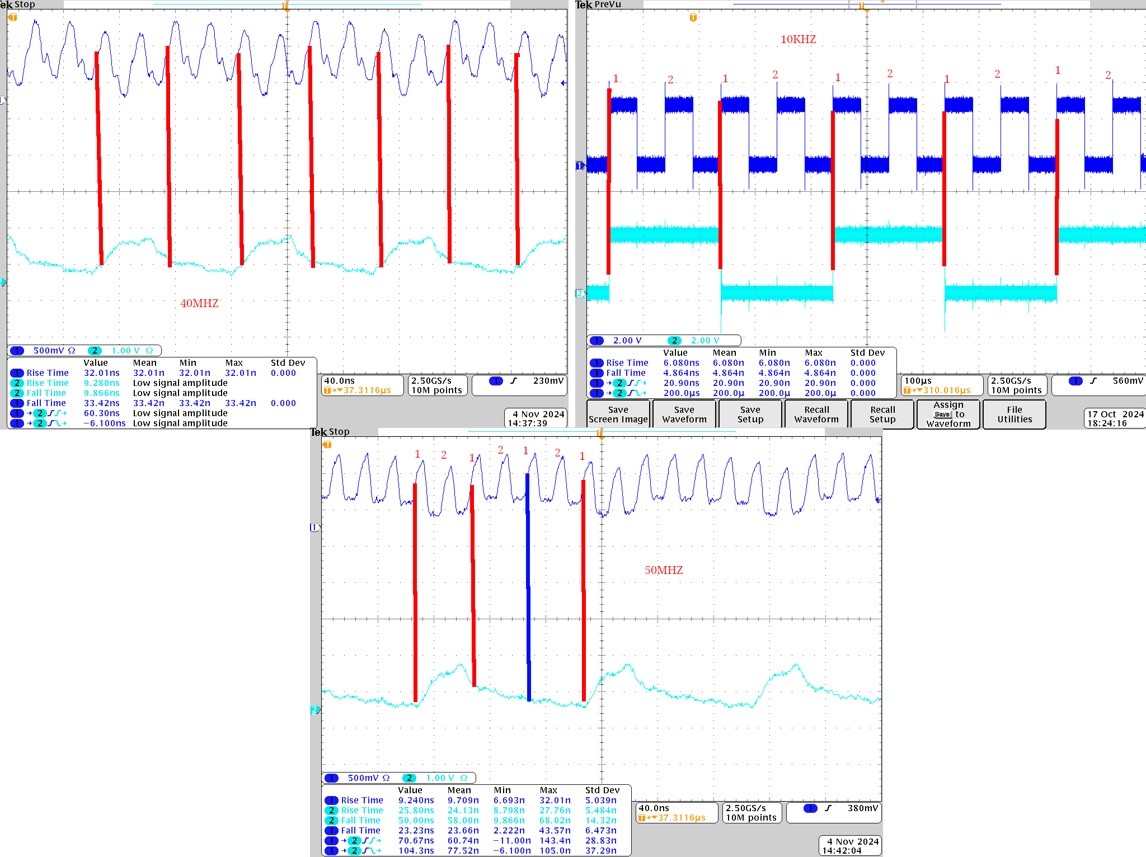

Figure 11 Analysis of errors of the circuit, clocks vs output

The propagation delay and timing of the circuit on the other hand is shown in the table below. Some of the values were not recorded because they were too messy to be accurate.

| Speed | Propagation Delay Low to High in ns | Propagation Delay High to Low in ns | Rise Time (output) in ns | Fall Time (output) in ns |
| --- | --- | --- | --- | --- |
| 10KHz | 20.4 | 27.33 | 26.96 | 54.08 |
| 1MHz | 27.70 | 22.27 | 27.96 | 55.68 |
| 10MHz | 28.45 | 20.37 | 30.88 | 101.1 |

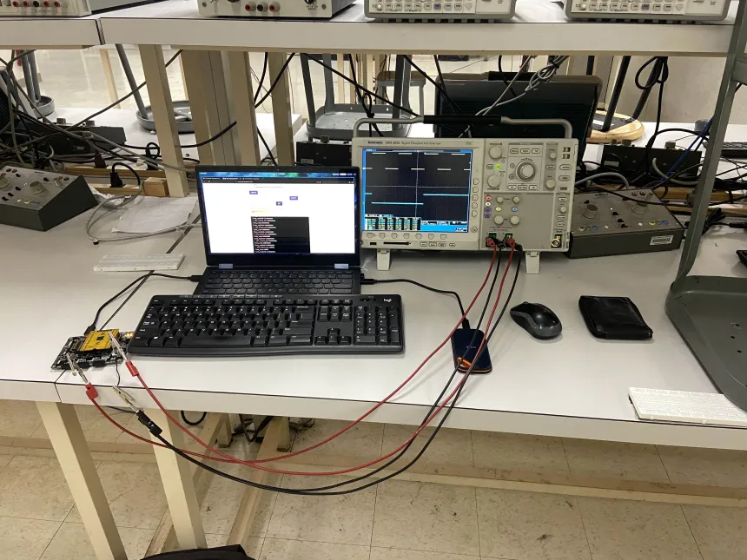Figure 12 Image of the Oscilloscope set up  
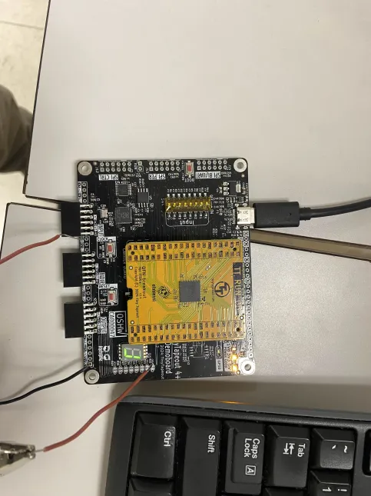

Image of the connections on the TTO board